FOOD -CASE STUDY

In this case study, we will explore a simple food ordering system for a small restaurant. The system tracks customer information, food orders, and order details, allowing the restaurant to manage and analyze their sales effectively. We will use SQL to create and manage the necessary database tables, insert sample data, and perform various queries to extract valuable insights.

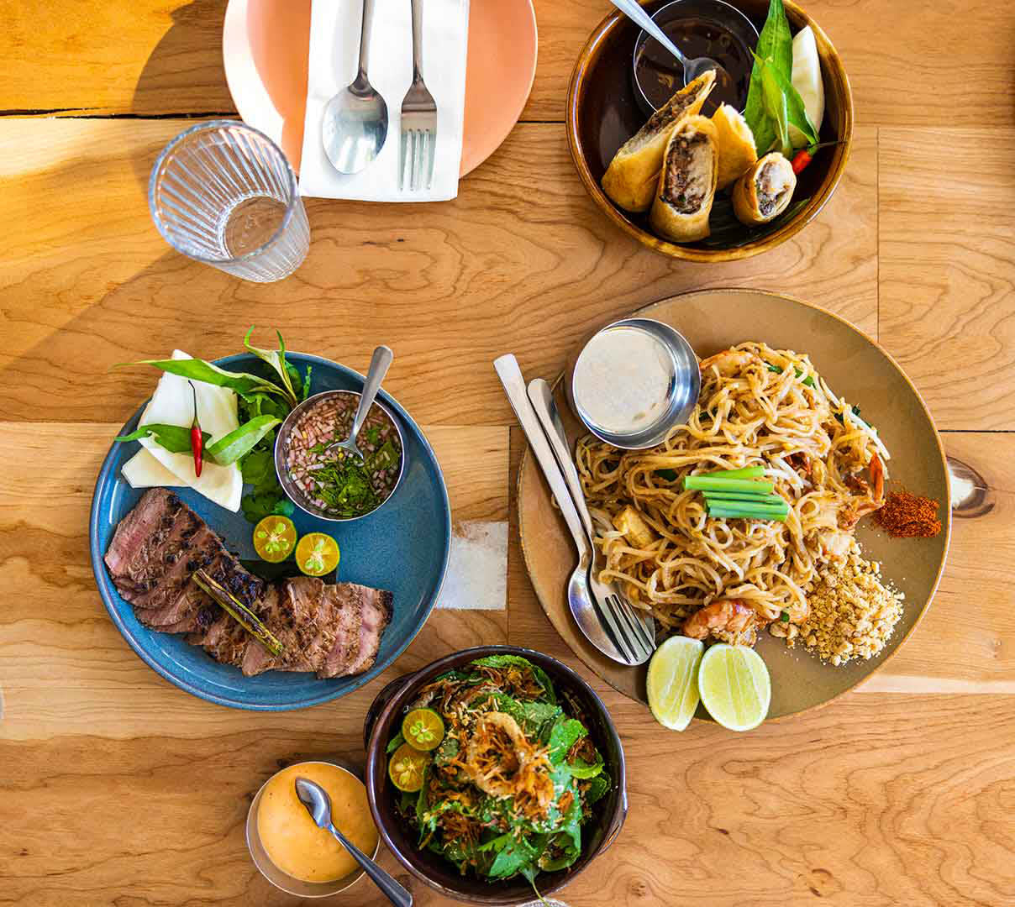

TO Create an new database in my SQL workbench.

Syntax: create database food;

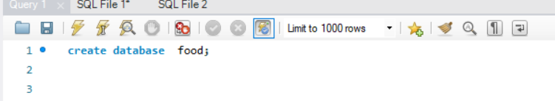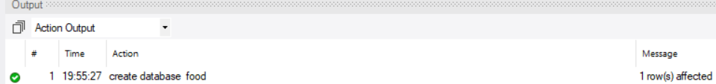

Use the database which we have created .

Syntax: use food;

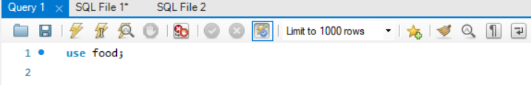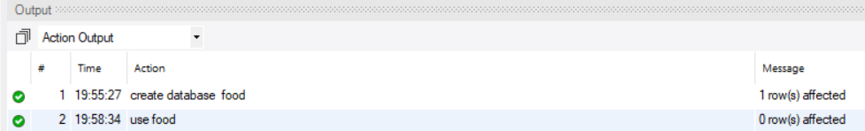

Step 1: Creating the Tables

We'll create two tables: food_orders and customers.

TABLE 1:

Creating an customers table in food database and inserting an values of customers table.

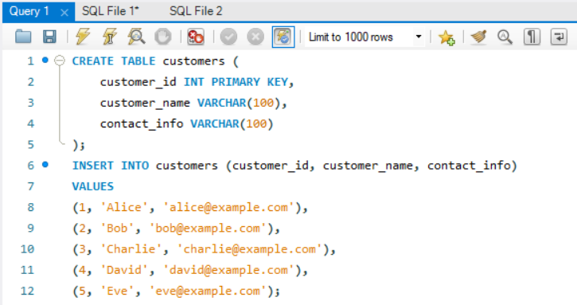

Select * from customers;

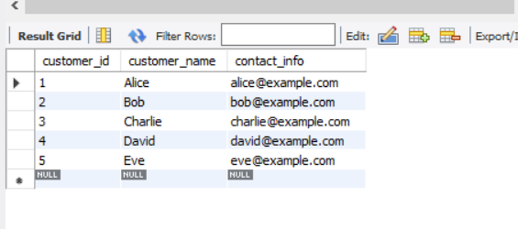

Table 2:

Creating an food_orders table in food database and inserting an values of customers table.

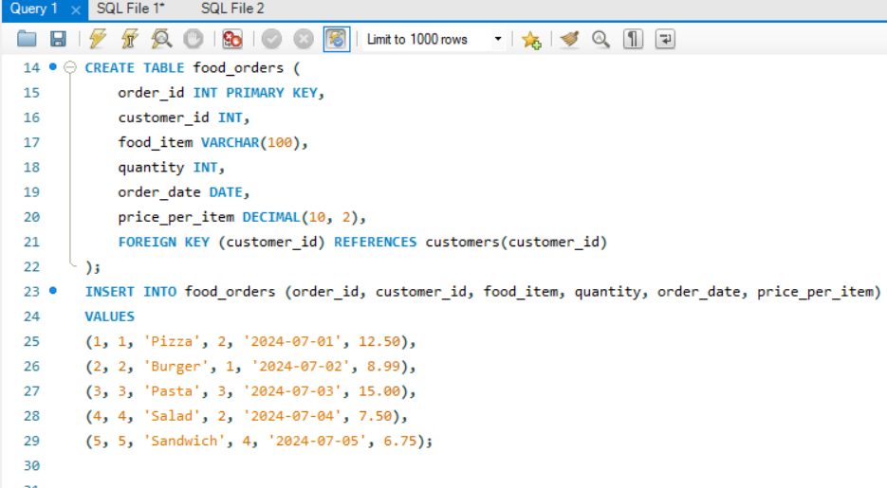

Select * from food_orders;

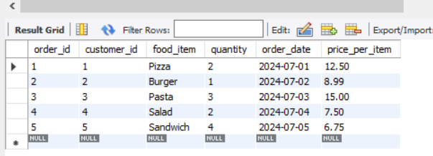

CASE STUDY QUESTIONS

1. List all food orders with their details.

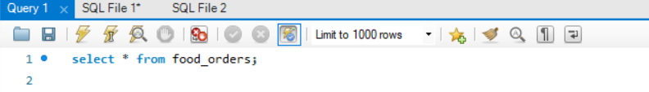



1. Calculate the total cost for each order.

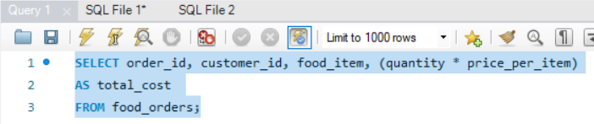

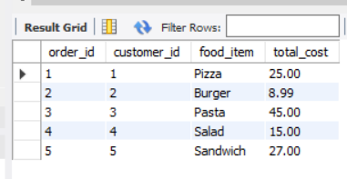

1. Find the total quantity ordered for each food item.

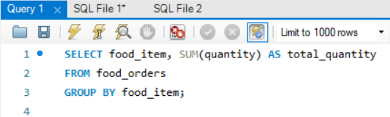

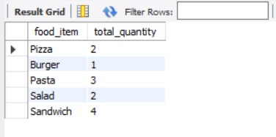

1. Find the order with the highest total cost.

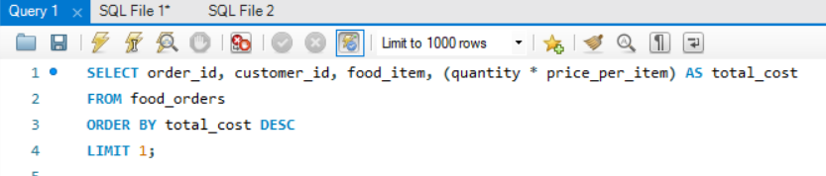

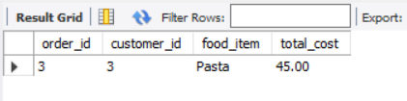

1. Get the total revenue generated from all orders.

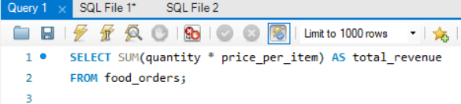

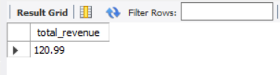

6.